**Que.1) How much Diamonds were looted from Chennai Port Trust?**

Ans. – 7182 ounces.

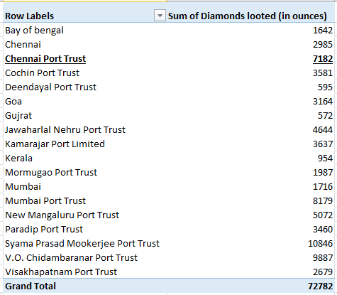

**Que.2) How many Ships were looted near Paradip Port Trust and Chennai Port Trust?** Ans. – Ships looted near Chennai Port Trust: 2

Ships looted near Paradip Port Trust: 3

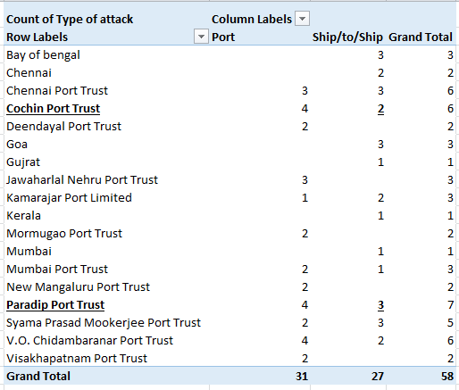

**Que.3) What is the sum total of Diamonds looted from the V.O. Chidambarnar port trust?** Ans. – 9887 ounces

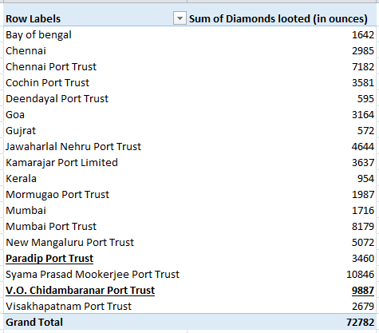

**Que.4) What is the average amount of Diamonds and Soft drinks looted?**

Ans. – Average amount of Diamonds Looted: 1254.86 ounces.

Average amount of Soft Drinks Looted: 2227.76 gallons.



Que.5) What is the ratio of soft drinks drunk to soft drinks looted? Ans. – 0.392

